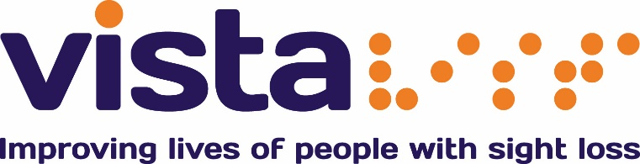

Volunteer Role Description

Title: Graphic Design Volunteer

Responsible to: Marketing Manager

Expected Commitment: 1 day a week

Location: Vista House, 1a Salisbury Road, Leicester, LE1 7QR

About Us:

Vista changes lives. We are the leading charity working with children and adults with sight loss in Leicester, Leicestershire and Rutland.

Primary Objectives:

We’re looking for a Graphic Design volunteer to help support our marketing team here at Vista. The role will require visual communication skills to develop ideas that inspire, inform and captivate our service users and visually impaired people in Leicester, Leicestershire and Rutland.

The role will involve developing and editing original artwork and templates, as well as creating new designs for advertisements in local press and other media, retail - point of sale, designing posters for the many services we offer as well as other Vista print materials.

Responsibilities:

- Developing ideas alongside the marketing team according to Vista’s brand and ‘Vista’s Make it Clear Guidelines’.
- To assist with the development and production of some of Vista’s marketing and publicity materials, using InDesign software package
- To support internal design work for new office move
- To assist the Marketing and Communications Assistant in other design tasks as required

Qualities and skills we are looking for:

- Confident user of Adobe creative suite and InDesign packages
- Ability to follow a work plan and stick to deadlines
- Visually communicate and aesthetically express concepts and ideas using various graphics elements and tools
- Ability to work well under pressure
- Attention to detail
- Good written skills
- Ability to manage time effectively, prioritising workload to manage multiple projects
- Confident, friendly and reliable with a genuine desire to make a difference to the lives of visually impaired people

Support provided for you:

- Visual Impairment Awareness training will be provided and take place at Vista

- Other training as identified

- Reimbursement of out of pocket expenses such as mileage or public transport costs.

We hope that by becoming a volunteer you:

- Increase your own self confidence

- Meet new and interesting people

- Learn new skills that could be helpful for future employment opportunities or further learning

- Have fun!

Health & Safety:

- Take reasonable care for the Health & Safety of themselves and others whom may be affected by their acts or omissions whilst volunteering.

This volunteering opportunity is suitable for volunteers aged 18 years and subject to two references.

Next steps:

For an Application form
Contact the Volunteer Manager Rayhana Brydson
Call 0116 249 8843
Or email volunteering@vistablind.org.uk.
Vista House, 1A Salisbury Road, Leicester, LE1 7QR

