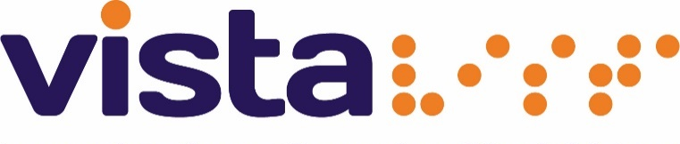

Volunteer Wanted: Children’s service

Expected Commitment: Varied days in the school holidays and one Saturday a month

Location: Within Leicestershire

Responsible to: Children Services

About Us:

Vista changes lives. We are the leading charity working with children, young people, and adults with sight loss and complex needs in Leicester, Leicestershire and Rutland.

Primary Objectives:

We’re looking for enthusiastic volunteers to help with our children’s trips and activities during school holidays times.

We arrange some exciting and fun activities and challenges empowering young people with sight loss to grow confidence.

You could research and arrange these with us or could volunteer to attend and assist young people in the activities.

We need positive, energetic and caring individuals who would like to make a difference in the lives of young people with sight loss.

Responsibilities:

- To empower the children and young people

- To socialise with children, young people and families, taking part in activities as necessary
- To be reliable and have a genuine desire to make a difference to the lives of visually impaired people.
- To help create a warm, friendly and welcoming atmosphere

Qualities and skills, we are looking for:

- Good people and communication skills

- Enjoys meeting new people

- Good team player

- Reliable

Support provided for you:

- Visual Impairment Awareness training
- Safeguarding training

- Regular newsletters, updates and news from the Group Facilitators and/or Volunteer Manager at Vista

- Other training, such as Health & Safety, as identified

- Reimbursement of out of pocket expenses such as mileage or public transport costs.

We hope that by becoming a volunteer you:

- Learn new skills that could be helpful for future employment opportunities or further learning
- Help us to make a difference to people with sight loss
- Increase your own self confidence

- Meet new and interesting people

Health & Safety:

All volunteers will be expected to:

- Ensure that they comply with Vista’s Health & Safety policy at all times

- Take reasonable care for the Health & Safety of themselves and others whom may be affected by their acts or omissions whilst volunteering.

This volunteering opportunity is suitable for volunteers aged 18 years and above and is subject to a DBS check and 2 references.
Next steps:

For an Application form Call 0116 249 8843 or
email volunteering@vistablind.org.uk.
Vista 3rd floor, 16 New walk Leicester LE1 6UB

