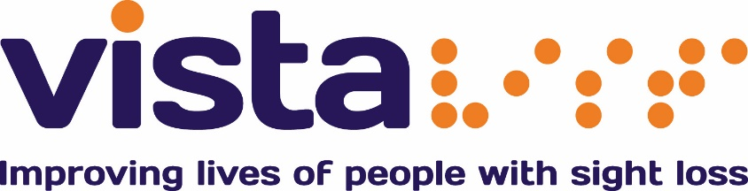

Vista is the local sight loss organisation for Leicester, Leicestershire and Rutland.
Four years ago, we asked the people involved with Vista what kind of organisation they wanted Vista to be.
This led to the Strategic Direction “Improving the lives of people with sight loss.”
The world has continued to change and so we’re asking again, what kind of organisation do you want Vista to be?

1) What is your relationship with Vista?
I use Vista’s services
I have sight loss but do not use Vista’s services
I have a family member who has sight loss
I am a professional
I am a member of staff
I am a volunteer
I fundraise for Vista
I donate to Vista
Other (please specify on the next page)

Sector wide questions

2) How do you feel the future is for people with sight loss?
Negative
Somewhat negative
Somewhat positive
Positive

3) What do you think the future holds that will be positive for people with sight loss?

4) What do you think the future holds that will make life more difficult people with sight loss?

Service specific questions
5) In the age of social media and online communities, what is the role for a local organisation?

6) Should Vista continue to focus on sight loss, or should the charity also work with other groups of people?
Focus on sight loss
Work with other groups

7) Should Vista offer services in other parts of the country?
Yes
No

8) Should Vista remain a service-providing charity, or is there benefit in campaigning?
Service providing
Campaigning organisation

Vista currently provides the following services:
- Care homes for older people with sight loss
- Care homes for people with learning disabilities and sight loss
- Support for people who are deafblind
- Rehabilitation services for adults
- Befriending
- Social groups
- Talking newspapers
- Low Vision Clinic
- Eye Clinic Liaison Officers
- Habilitation for children and young people with sight loss
- Children’s activities and residential holidays
- Children’s vision screening
- Family support
- Leicester Ageing Together
- Providing aids to daily living (equipment)
- Bursary scheme

9) Are there any current services (listed above) that you think will be obsolete in the future?

10) Are there any services that you thought would be provided, but are not provided?

11) How prepared do you think Vista is for the upcoming five years?
Not prepared
Not very well prepared
Quite prepared
Very prepared
Don’t know

Please tell us a little bit about you

12) Do you have a sight loss?
Yes
No

13) Gender:
Male
Female

14) Age:
Under 18
18 - 25
26 - 39
40 - 49
50 - 59
60 - 69
70 - 79
80+

Thank you for your time in completing this survey, your feedback is valuable to us.

For more information, please call our Helpline on 0116 249 8839.

