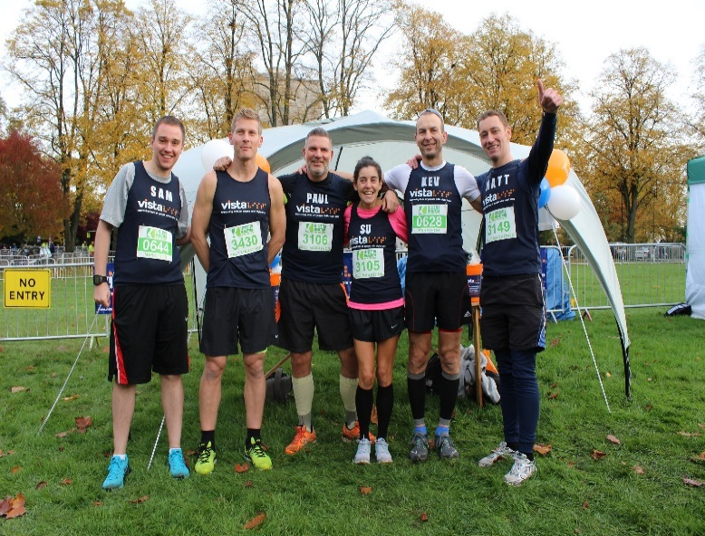

Title | Full name | Home address | Postcode | Gift aid (please tick) | Amount pledged | Contact me (see below) | Date received
Please sponsor me! All funds raised will go towards Vista’s lifechanging services and support across Leicester, Leicestershire and Rutland for adults and children with sight and dual sensory loss.
Every contribution, no matter the size, brings us one step closer to a world where sight loss does not limit potential. Your generosity can light up someone’s life and give them the tools they need to thrive. Donate today and be a beacon of hope for those living with sight loss.
Gift Aid it! Turn £1 into £1.25 without spending an extra penny. To qualify for Gift Aid, what you pay in income tax or capital gains must be at least equal to the amount we will claim on your donation in the tax year. I understand that if I pay less income tax and/or capital gains tax than the amount of Gift Aid claimed on all my donations in that tax year it is my responsibility to pay any difference. By ticking this box and supplying your full name and postcode, Vista can claim an extra 25p for every £1 donated.

Image description: six people stand in a park with trees behind them, posing for a photo in their running attire, smiling at the camera. They are wearing Vista branded T shirts.
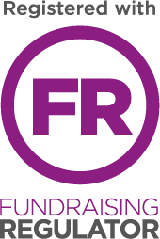

Title | Full name | Home address | Postcode | Gift aid (please tick) | Amount pledged | Contact me | Date received

Contact me
Your support changes lives. Tick the contact me box to keep up to date with our news and events.

Thank you!
Your support is really appreciated. Please return your form and sponsorship money to:
Fundraising Team
Vista, 3rd floor Provincial House,
37 New Walk,
Leicester
LE1 6TE
Please make cheques payable to Vista.

